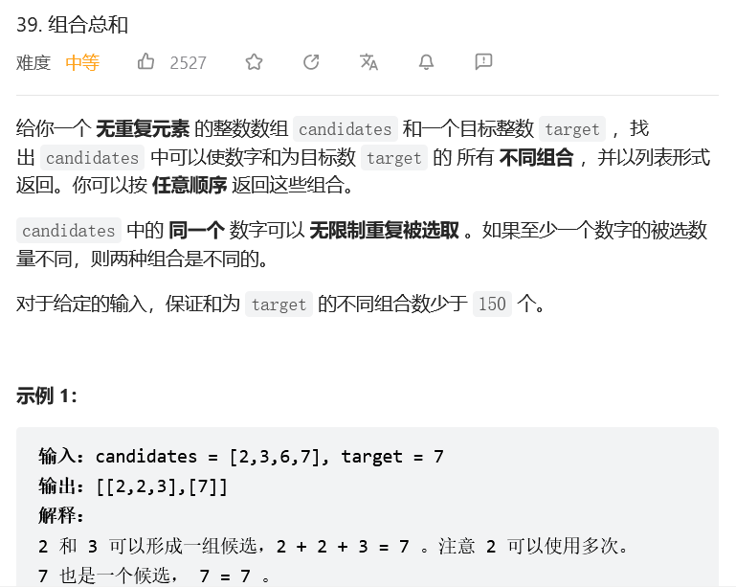
回溯法
class Solution:
def combinationSum(self, candidates, target):
res = []
def combination(candidates,target,res_list):
if target < 0:
return
if target == 0:
res.append(res_list)
for i,c in enumerate(candidates):
# 为了避免重复 (例如candiactes=[2,3,6,7],target=7，输出[[2,2,3],[3,2,2][7]])
# 传到的下一个candicate为candicates[i:]
combination(candidates[i:],target-c,res_list+[c])

combination(candidates,target,[])
return res
